**Sprint 2 Plan - CMPS 115**

# Heading

**Document’s name**: Sprint 2 Plan

**Product name**: My Fitness Program Distributor

**Team name**: Fitness Team

**Sprint Completion date**: 7/16/2019

**Revision number**: 2.0

**Revision date**: 7/9/2019

# Goal

1. Finish implementing pages where users can search workout programs and routines with some filters, which we could not finish in sprint 1 (1st high-level goal)

2. Implement pages where users can make their own workout programs. (2nd high-level goal)

# Task listing, organized by user story

**User Story 1**: (From sprint 1) (total 23 hours)

As a user, I want to filter the programs or routines with some options so that I don't have to see entire data.

* Task 1 (1 hours) : Edit the previous design of option block.
* Task 2 (4 hours) : Make filtering function which gets filtering options and returns list of programs or routines that satisfy the options.
* Task 3 (7 hours) : Show filtered result in html page.
* Task 4 (4 hours) : Create view page for single program and routine.
* Task 5 (7 hours) : Manage general data set and parsed data set for programs and routines. (including managing parser)

**User Story 2**: (total 25 hours)

As an experienced fitness user, I want to design my own customized program since the provided programs do not align with my goals.

* Task 1 (4 hours) : Create a logic to manage items like exercises and days in front-end.
* Task 2 (12 hours) : Design and implement UI page for customization.
* Task 3 (9 hours) : Design and implement page where users can review the result of their customized programs. (in modal)

# Team roles

Duc Nguyen: Product owner & Developer

Dongpyeong Seo, Cameron Rabiyan: Scrum master & Developer

Tunglin Lee, Tarun Sivakumar, Matthew Stone: Developer

# Initial task assignment

Duc: User story 1, Task 4 – Create view page for program and routine.

Dongpyeong: User story 1, Task 1 - Edit previous design of option block.

Cameron: User story 1, Task 1 – Edit previous design of option block.

Tunglin: User story 1, Task 4 – Create view page for program and routine.

Matthew: User story 1, Task 5 - Manage general data set and parsed data set for programs and routines. (including managing parser)

Tarun: User story 1, Task 1 – Edit previous design of option block.

# Initial burnup chart

# Initial scrum board

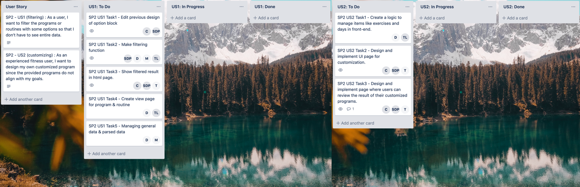

# Scrum times

Daily Scrum meeting : three times a week; Tue 15:00, Thu 16:30, Sat 14:30